**Hi my name is Leanne and I am the social Prescribing Link worker (SPLW) for Dengie PCN**

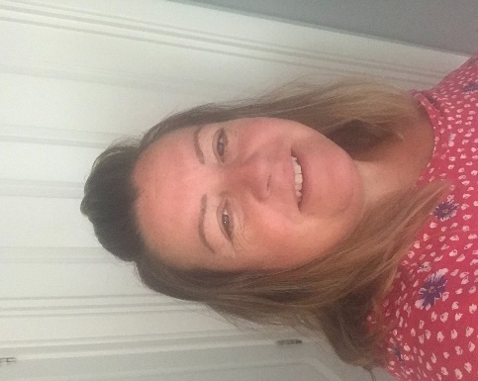

**What is social Prescribing**

Social Prescribing is a **non-medical** **non-Urgent** referral option for patients

* With one or more long term conditions
* Who need support with their mental Health
* Who are lonely and isolated
* Who have complex social needs which affect their wellbeing

**During Covid 19 SPLW are also making Welfare calls to vulnerable patients,arranging food shopping and medication delivery, offering emotional support and more**

**Patients can be referred to social prescribing for any of the following issues**

Benefits/Finance/form filling Social Isolation/Loneliness

Bereavement support Domestic abuse referrals

Carers services Advocacy support

Social Activities/Community groups Housing support

Counselling Options Weight/Lifestyle changes

Emotional Wellbeing support Volunteering/Training Opportunities

**Who can refer?**

Anyone can refer to me, including self-referral as long as you are a patient registered at one of the surgeries listed below.

* **Dengie Medical Partnership**
* **William Fisher medical Centre**
* **The Trinity medical Practice**
* **The Burnham Surgery**

**How can I refer?** Contact details: [leanne.smith33@nhs.net](mailto:leanne.smith33@nhs.net)

07580912184